

INTERNSHIP PORTFOLIO HBO-ICT
FONTYS UNIVERSITY OF APPLIED SCIENCES

Student:
Family name, initials: | Stijlaart. C.
Student number:
project period: (from – till) | 06.02.2023 –
Company:
Name Company/institution: | Edorado Marine
Department: | Technology, Embedded Software
Address: | Leerparkpromenade 50, Dordrecht
Company tutor:
Family name, initials: | Meijer. P.
Position:
University tutor:
Family name, initials: | Van Gastel. F.
Final portfolio:
Title:
Date:

Approved and signed by the company tutor:
Date:
Signature:

Internship Portfolio

Retraction System

Edorado Marine
Dordrecht, The Netherlands

Date : 28.05.2023
Version : 0.6
Status : Draft
Author : Casey Stijlaart
Table of Contents
1. Introduction 7
2. The Company 7
3. Assignment Overview 8
3.1 Initial Situation 8
3.2 Assignment Description 8
3.3 Constraints 9
3.3.1 Time 9
3.3.2 Technology Stack 9
3.3.3 Scalability 9
3.4 Methodology and Tools 9
3.4.1 Methodology 9
3.4.2 Tools 10
3.5 Research 10
3.5.1 Research Strategies 10
3.5.2 Research Questions 10
3.6 Assignment Phasing 11
4. Process and Results 12
4.1 Analysis 12
4.1.1 The Architecture 12
4.1.2 The Initial State 13
4.1.3 The Hardware 13
4.1.4 The Requirements 14
4.2 PCB : The Hardware Actuators 15
4.2.1 Objective 15
4.2.2 Approach 15
4.2.3 Result 15
4.3 Triton : Communication 15
4.3.1 Objective 15
4.3.2 Approach 15
4.3.3 Result 15
4.4 PCB : Communication 15
4.4.1 Objective 15
4.4.2 Approach 15
4.4.3 Result 16
5. Conclusion(s) and Recommendation(s) 17
6. Evaluation and Reflection 17
7. References 17
8. Attachments 17

Table of Figures
Figure 1. Retraction system (gif) 8
Figure 2. Scrum methodology 9
Figure 3. System Architecture 12
Figure 4. PIC32MK Curiosity Pro 13
Figure 6. Linak LA36 Actuator 14
Figure 7. Component Diagram 14

Foreword
This report represents the activities and processes that have been carried out during the last five months of my internship at Edorado Marine, Dordrecht. Working at Edorado Marine brought me many new opportunities and experiences to grow from.

// Thank words
Summary
Edorado Marine is an innovative start-up company developing an electric powerboat in Dordrecht. Edorado Marine aims to make recreational sailing fully electric, thus 0% fuel emission pollution for the environment.

The company has multiple teams, each with their field of expertise. These fields range from marketing to machinal engineering to software development. For my internship I have joined the User Interface team, consisting of back- and front-end developers.

At the start of my internship, the company had a working prototyping – capable of basic functionality, such as sailing, ‘flying’ in a simple manner. However, there is no direct connection between the dashboard and the retraction stern. All the operations, regarding the retraction stern, were performed by using simple operations – buttons and switches.

My assignment was to develop the retraction stern software and set up the communication between the retraction stern and the dashboard – allowing for the retraction stern to be controlled based on the communication that takes place.

The project was split into 10 sprints with daily standup meetings and biweekly Scrum planning meetings. These meetings were used to ensure the progress of the project and to discuss the next assignment(s).

The first sprint was used to gain familiarity with the company and the project. Next to this, there was prepared to start on the actual assignment, this was done by defining the programming language, the hardware specifics and the overall system.

From the second sprint on, the V-shape of working has been implemented – research a sub-part of the system and implement this.

During the last two sprints, the focus was on tying all the components together and implementing the last functionalities.

Throughout the internship, the DOT research framework is used to research, apply and validate my findings and work.

Glossary
Microservice Architecture:
Microservice Architecture is a software development approach in which an application is divided into smaller and independent services. These services can be developed and deployed without the other connected services. Each service focuses on a specific functionality and can communicate with other services.

C++:
C++ is a programming language that extends the capabilities of the C programming language. It supports object-oriented programming principles and provides classes, templates, and exception handling. C++ is widely used for developing high-performance applications and systems software.

Visual Studio Code:
Visual Studio Code is a cross-platform source code. It provides a wide range of features, including syntax highlighting, code completion, debugging capabilities and integrated Git support.

Docker:
Docker is an open-source platform that enables developers to automate the deployment using containerization. Containers provide a lightweight and isolated environment in which applications and their dependencies can run consistently across different systems.

GitHub:
GitHub is an open-source platform that provides version control and collaboration functionalities for software development projects.

Slack:
Slack is a communication tool that enables communication within a team. Slack has the option to provide an organized environment by using different topics/channels.

Dropbox:
Dropbox is a cloud storage application that allows users to store and share files across different devices and platforms. Teams use it to easily share and collaborate on files.

Scrum:
Scrum is an agile form of project management that focuses on iterative and incremental development. It involves dividing work into short sprints. At the end of a sprint, the outcome will be showcased and new goals will be assigned.

CMake:
CMake is an open-source build system that helps to automate the process of building software. It makes use of configuration files (CMakeLists.txt) to generate native build scripts for various build tools and platforms, such as Makefiles.

Hydrofoils:
Hydrofoils are wing-like structures mounted under the watercraft that provide lift and reduce drag, enabling the boat to rise out of the water and achieve increased speed and efficiency.

Retraction system:
The retraction system is a mechanical system that allows for the retracting and extending of the hydrofoils. Within the retraction system actuators are used to allow for control of the extending and retracting.

Introduction
Everywhere one wanders, they are surrounded by the advancements of modern technology and the vast possibilities it offers. From the ubiquitous presence of smartphones in our daily lives to the increasing adoption of fully electric cars, technological innovations have transformed numerous industries and revolutionized the way we live. However, amidst this rapid progress, one industry has remained relatively stagnant in terms of environmental sustainability—the boat industry.

Boats, which have long been associated with leisure, adventure, and exploration, continue to rely on conventional combustion engines that emit carbon dioxide and other pollutants into the air and water. This contributes to environmental degradation and poses a significant threat to the fragile ecosystems that our oceans and water bodies sustain. We must address this issue and envision a future where boats can navigate our waters without leaving a harmful environmental footprint.

Imagine the immense impact and potential of introducing a zero-emission powerboat to the market. This is where Edorado Marine comes into the picture. Edorado Marine a dynamic start-up company at the forefront of the marine industrial revolution, has taken up this challenge. They have recognized the pressing need to develop electric powerboats that offer both luxury and environmental responsibility. By harnessing the power of electric propulsion, Edorado Marine aims to redefine the concept of boating, setting new standards for performance, efficiency, and sustainability.

The Company
Edorado Marine is a small start-up company founded in 2014 by Giel Groothuis and Godert van Hardenbroek. The two individuals crossed paths in China while working on their projects. Once the time was there, they moved back to the Netherlands to start making their dream a reality.

All the different experiences and knowledge they gathered over the years, were put into the creation and realization of their idea, a luxury zero-emission electric powerboat with hydrofoils. Combining luxury and experience with the elimination of unnecessary environmental pollution.

As of today, the luxury powerboat market is relatively new. Only a handful of companies are trying to sail the waters of this market. Yet most of these companies are start-ups. Notable names of such start-up companies are Sea Bubbles from France and Candela from Sweden. Even though there are other companies out there, trying to sail these waters with Edorado Marine, Edorado is one of the most popular ones. Edorado has a proprietary technology and their design is outstanding.

Assignment Overview

Initial Situation
Edorado Marine has been developing the boat for the past few years now. Yet there is still a lot to do regarding the embedded software. Due to the company still being in its early years, there here have not been enough embedded software developers to tackle all the problems that still need to be solved.

As of before the internship, the boat did not have an integrated retraction system, meaning that the UI and the retraction system are not connected. Due to the missing link between these two components, the retraction stern is currently being operated in a simple manner, using buttons and switches.


Figure 1. Retraction system (gif)

Assignment Description
The assignment is to set up the retraction system and have it be able to communicate with the microservice, which is connected to the dashboard. The overall system should be able to receive messages from Poseidon through Triton to the PCB, execute behavior and return a message to Poseidon over Triton again. All though it seems straightforward, there is more to it than it first seems. There are multiple services connected and must work together, to make one cohesive software application. Each of these services, PCB, Triton and Poseidon, has its responsibility, but should work together.

Next to the overall communication between the mentioned microservices, there will be worked on the software for the PCB as well. The PCB takes care of the extending and retracting of the actuators and must be able to execute this behavior based on the message input.

Constraints

Time
The project should be completed before the 23rd of June 2023, which is the date the internship ends. The project itself should be finished before this date, depending on when the final presentation will take place. Nevertheless, there will be worked within the company until the end date.

Technology Stack
There are multiple constraints regarding the technology stack. These constraints are the programming language, communication protocol and tools.

- The programming must be done in C++. Using C++ allows for better maintenance, data encapsulation and modularity.
- The communication that takes place between the different microservices should be serial or ethernet, depending on the microservice. To clarify, the PCB should communicate with Triton over serial communication and Triton should communicate with Poseidon over ethernet.
- Specific tools, such as ZeroMQ and spdlogger, must be used.
- Lastly, the hardware for the specific microservices is already established and therefore these need to be used to build on/with.

Scalability
It must be possible to extend upon the created software. Next to this, the software should allow for modularity.

Methodology and Tools

Methodology
Throughout the duration of the project, the Scrum methodology is applied. The Scrum methodology divides the project into multiple sprints of 2 weeks each. The sprints include daily stand-ups, sprint demos and sprint planning. The scrum master, Angel Hadziev, manages the sprints. Ensuring everything is going smoothly. Having this methodology allows for a better workflow and an easier way to manage tasks and overall performance. A detailed overview of the sprints can be found in 3.6 Assignment phasing.

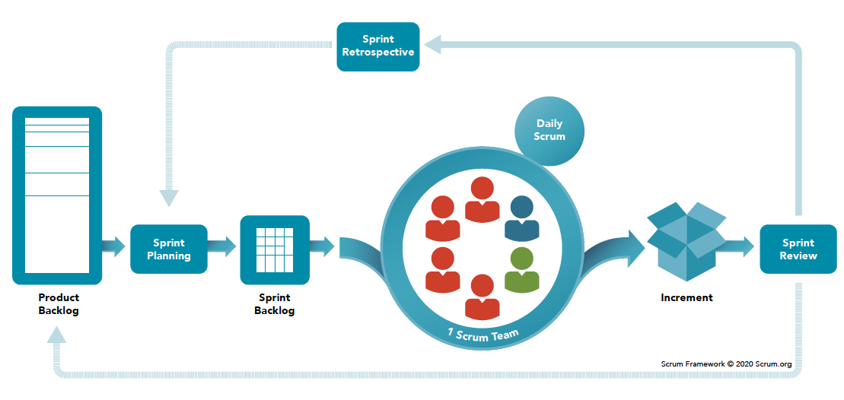
Figure 2. Scrum methodology

Tools
There are multiple tools used, each serving its purpose. They can be divided into different sections.

Communication
The communication between the team is done with the help of Slack and Skype. These two platforms allow for a better flow. Especially Slack allows for a great flow. This platform allows for different channels, allowing for a clean and clear way of communication regarding different parts of fields within the software development of the boat. Skype is used for daily stand-ups.

Storage
Storing files is divided into two different sections. Non-code-related files are stored in Dropbox. Anything code related is stored in GitHub. It allows for clear version control of the code base. Besides that, it has many other functionalities that allow for peer reviews, branches to protect their already good code and more.

Programming
For the development of the software, multiple platforms are used. To allow for a manner of programming different Integrated Development Environments (IDEs) are used, such as Visual Studio Code and MPLAB X IDE. Next to this, there is made use of Docker to run containers for a Linux OS.

Research

Research Strategies
To research the different aspects of the project, the DOT framework research methodology is applied. The DOT frameworks stand for Development Oriented Triangulation. This type of framework fits well with applied research. Applied research is focused on gaining knowledge by research and applying this to the problem. Further details on this can be found in the project plan, (Stijlaart, 2023, pp. 6 - 7).

Research Questions
Each of the mentioned research questions is to give a clear direction of where the project must be headed to. The research questions are answered with the help of the research strategies, more about this can be found in the project plan, (Stijlaart, 2023, pp. 6 - 7).

Main research question
How to achieve reliable and secure communication between the Triton and the retraction PCB, allowing for the connected hardware, to the PCB, to operate as expected?

Sub-research questions
The main research question can be divided into multiple sub-questions. These are as follows:

Specification
- What is the current state of the retraction system?
- What are the system requirements?
- How must the retraction system behave to deliver to correct output?
- Which communication protocol will be used?

Hardware research
- Which hardware will there be used?
  - Which actuators are used within the retraction system?
  - Which development board will be used?
- How will the retraction system be directed?
- How does the retraction system work?
  - How do the actuators operate within the retraction system?
  - How will the actuators be controlled to deliver the wished-for behavior?

Assignment Phasing
The project at Edorado Marine was approached in a Scrum manner, employing an agile framework that emphasizes setting clear goals and working towards them with continuous feedback and adaptation. This methodology allowed for a structured and iterative approach to project management, ensuring that progress was made efficiently and collaboratively.
At the start of the internship, the initial focus was on conducting thorough research. This research phase was crucial as it laid the foundation for the project, providing essential insights and understanding of the initial situation. However, even with all the research that had been done, there were still many unknowns and uncertainties. The answers to all of the unknowns and uncertainties were discovered throughout the sprints after.
After the first initial phase, the actual sprints kicked off. During these sprints, the focus was on setting achievable goals that aligned with the project goal. The goals were decided with the help of insights gained from previous sprints and with feedback and suggestion. Breaking down the project into smaller, manageable tasks made it easier to track progress and make adjustments as needed.
Throughout the next chapter, 4. Process and Results, the sprints itself are discussed more in-depth.

Process and Results
In this chapter, we delve into the process of completing the project and present the corresponding results. To provide a better understanding, the chapter is divided into multiple sub-sections, each focusing on a specific aspect of the project. This approach aligns with the project's V-shape execution methodology, where each aspect is thoroughly researched and implemented on individual devices in either the current sprint or the subsequent sprint. By examining each aspect individually, we gain valuable insights into the methods employed, the challenges encountered, and the outcomes achieved.

The sub-sections analyze the various stages of the project, providing insights into the methods, challenges, and outcomes associated with each aspect. Within each sub-section, all the different aspects are taken into account and discussed. These aspects are the research, decisions and implementation. Additionally, we evaluate the outcomes and assess their alignment with the project’s objectives.

Throughout the discussion of the sub-sections, there is referred to the SOLID principles, which serve as fundamental guidelines for designing software that is easy to understand, maintain, and extend. The principles act as a guide for developers, lending a helping hand in creating robust and flexible software systems. Let's now explore each sub-section in detail, considering the SOLID principles as a key framework for analysis and evaluation.

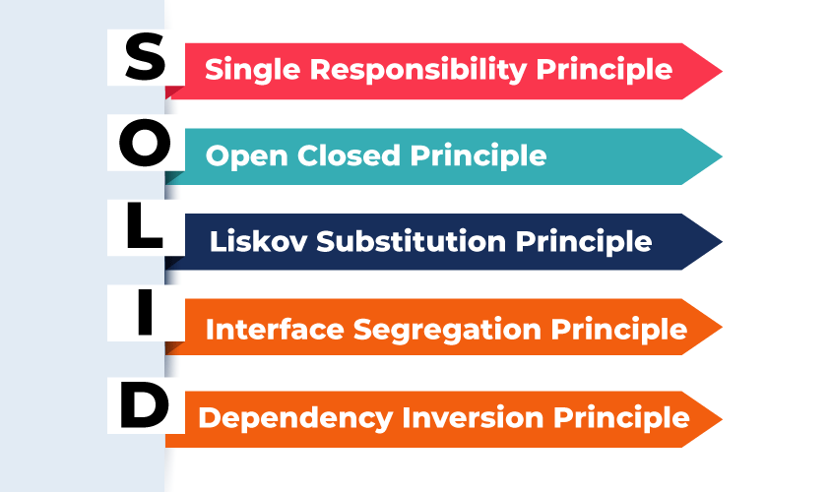
Figure 3. SOLID principles

Analysis
To develop an effective system, a thorough inventory of the basic system aspects was conducted. These aspects are the architecture, hardware components, their connections, the current state of the system, and the project requirements. Each of these aspects played a crucial role in laying the foundation for the project.

The Architecture
The system exists out of different components, each serving its purpose in the complex system. For the project, the focus is on the retraction stern and Triton and indirectly Poseidon. These three components play crucial roles in enabling the electric powerboat to achieve a "flying" state with the assistance of the dashboard.

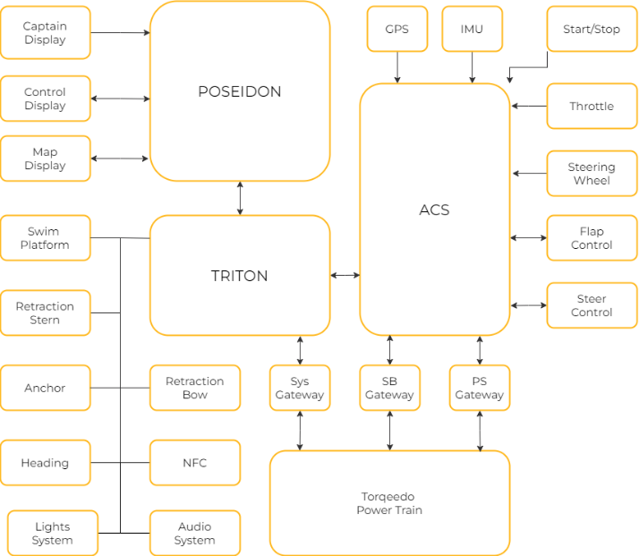
Figure 4. System Architecture
The Retraction Stern
The retraction stern plays an important role in controlling and positioning the hydrofoils. By indirectly receiving input from the dashboard, the retraction stern adjusts the position of the hydrofoils, allowing for smooth and seamless transitions between the foiling and non-foiling modes.

Triton
Triton serves as an intermediary component, facilitating communication and integration between various hardware services and the dashboard. Acting as a central point, it connects different components of the system using different communication protocols. It ensures seamless data exchange and synchronization between the hardware components.

Poseidon
Even though Poseidon is not directly linked to the project, it does need to be taken into account. This service can be seen as the gateway between the microservice Triton and the dashboard. Allowing for a border and only relevant data to be sent from and to the dashboard.

The Initial State
As of the start date, the retraction stern was implemented simply by using an Arduino microcontroller. This approach was chosen to simplify the prototyping process and allow for a more accessible manner to get familiar with the chosen actuators.

During this stage, the primary focus was on understanding the basic functionality of the retraction stern rather than establishing two-way communication with other system components. The intention was to gain insights into the fundamental operation of the actuators and validate their compatibility with the system requirements.
Although the initial implementation with the Arduino microcontroller allowed for a simplified exploration of the chosen hardware, it became evident that for successful integration, the components need to be upgraded and allow for more and better performance and possibilities.

As for communication, efforts had to be made to develop a communication protocol and interface between the retraction stern and the other components. Developing both aspects will allow for enhanced performance and efficiency.

The Hardware
Since the hardware was already decided upon arrival, interviews with experts, my colleagues, were conducted. The hardware aspect of the system consists of several key components. These components are the development board, the connected service computer and the actuators.

The Development Board
The development board served as a crucial tool for prototyping and development purposes. In consideration of the future shift to the printed circuit board (PCB), certain factors were taken into account when selecting the development board. The main factor to be taken into account was chip compatibility, as it was essential to have a development board with a chip from the same family as the planned pic32mk chip for the PCB. Ensuring this aspect would allow the shift to go smoothly and the changes, in software, that should have been made regarding the device registers. Taking communication protocols into consideration, such as RS232 and CANBUS, the pic32mk1024mcf curiosity board pro was the best choice.

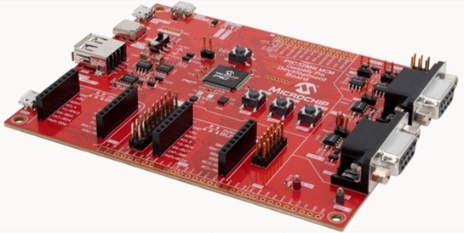
Figure 5. PIC32MK Curiosity Pro
Triton
For the Triton service computer, the IOT-GATE-IMX8PLUS was already decided upon. This computer, an industrial IoT gateway, operates on a Debian 11 OS. The choice of this specific service computer aligns with the project's requirements and provides the necessary computing power and stability for efficient system operation.

The Actuators
The actuators employed in the system are Linak LA36 actuators, which were chosen based on the recommendations of previous interns. These actuators are renowned for their precision and reliability in providing controlled linear motion. Their integration within the system plays a critical role in achieving the desired movements and functionalities, particularly for the hydrofoils.

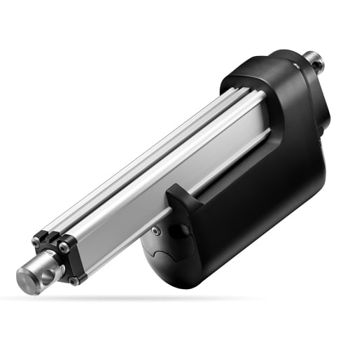
Figure 6. Linak LA36 Actuator

The Requirements
To ensure successful development and integration within the system, a set of requirements was established. These requirements will serve as the foundation and guidelines for the project. The set requirements are there to keep aim at the desired outcome, functionality. To set the requirements, interviews and discussions were held to get a clear insight into the vision the company has. With the provided answers, the following requirements were established :

  - Extensibility: The system must be designed in such a way that it can be easily extended in the future. This requirement aligns with the open/closed principle, which states that the system should be open for extension but closed for modification. By adhering to this principle, the system can accommodate future enhancements and modifications without disrupting its existing functionality.
  - Foiling and Non-Foiling : The hydrofoils must be able to switch between their foiling and non-foiling stages based on the communication input.
  - Affective Communication : Establishing effective communication channels is crucial for the seamless operation of the system. A two-way data connection must be established between the printed circuit board (PCB) and Triton, as well as between Triton and Poseidon. The communication between the PCB and Triton should be with a serial connection and the communication between Triton and Poseidon through ZeroMQ.

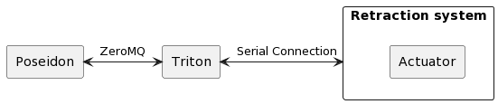
Figure 7. Component Diagram

PCB : The Hardware Actuators
In this section, the focus shifts to the hardware components of the retraction stern, specifically the actuators responsible for extending and retracting the system.

Objective
The objective is to explore the behavior and functionalities of the actuators within the retraction stern. Understanding how these actuators function is important to ensure the retraction stern is functioning properly and according to the expected behaviors. Additionally, the additional functionalities of the actuators, namely position reading and error detection, and their significance in enhancing system control and performance, are discussed.

Actuator Control and Functionality
The behavior of the actuators plays an important role in the operation of the retraction stern. The actuators within the retraction stern have the responsibility of controlling and positioning the actuators through the C++ application. The control commands for actuator movement are sent directly through the application, allowing for precise control over the actuators.

Main Actuator and Following Actuator
The actuators are designed in such a manner that only one actuator receives the order to run in or run out, the main actuator. This actuator can be seen as the control point of the actuator system. The others are designed to follow and mirror the movements of the control point, ensuring synchronized operations. This interconnected behavior between the main and following actuators allows for smooth and coordinated movement of the hydrofoils, minimizing the risk of misalignment or imbalance.

Additional Features
Apart from the primary function of controlling the position of the hydrofoils, the actuators have additional functionalities for enhanced system control and performance. These functionalities are position reading and error detection. To dive further into the advantages of reading the positions, it offers real-time feedback. It allows for an extra safety guard to ensure the actuators are working accordingly, moving when supposed to. Regarding error detection, the system can be warned at the moment of error and the error that has occurred. Ensuring the appropriate error handling and handling procedures can be taken to maintain a reliable and safe system.

Approach
As previously mentioned, the actuator has multiple functionalities and requires coverage on various aspects, including configuration and execution of behavior. In order to achieve a reusable, extendable, and easily adaptable application, an approach has been adopted that involves dividing the overall application into different classes, with each class having its own set of responsibilities. This approach aligns with the principles of Single Responsibility and Open/Closed.

With the goal of separating the configuration and executable behavior, we have created the following classes and structs, which are interconnected in the following manner:

  - ActuatorPins (struct): This struct is to provide a convenient way to manage and access the data from the actuator hardware pins.

  - Actuator (class): This class encapsulates the actuator's behavior and configuration. The class provides public methods for initializing the actuator, retrieving the position, extending and retracting the actuator and retrieving errors.

  - ActuatorConfiguration (class): This class handles the actuator's configuration. It manages the actuator pins and pin settings required for proper operation. It offers methods for configuring and initializing the actuator and its pins.

  - ActuatorData (struct): This struct stores data related to the actuator's errors, timer counts, and error counts. It is used by the ActuatorErrorhandler class to track and process actuator errors.

  - ActuatorErrorhandler (class): This class is responsible for handling actuator errors. It utilizes the ActuatorData struct to track all the different data. The class provides methods for processing error flags, resetting timer counters, retrieving error counts, and updating timer counts.

  - Timer1 (class): This class manages the actuator's timer functionality. It allows starting and stopping the timer, retrieving the current count, and handling timer interrupts.

  - PinSettings (class): This class provides a set of methods for managing pin states, such as setting pins to digital or analog mode, setting pins high or low, and retrieving pin states.

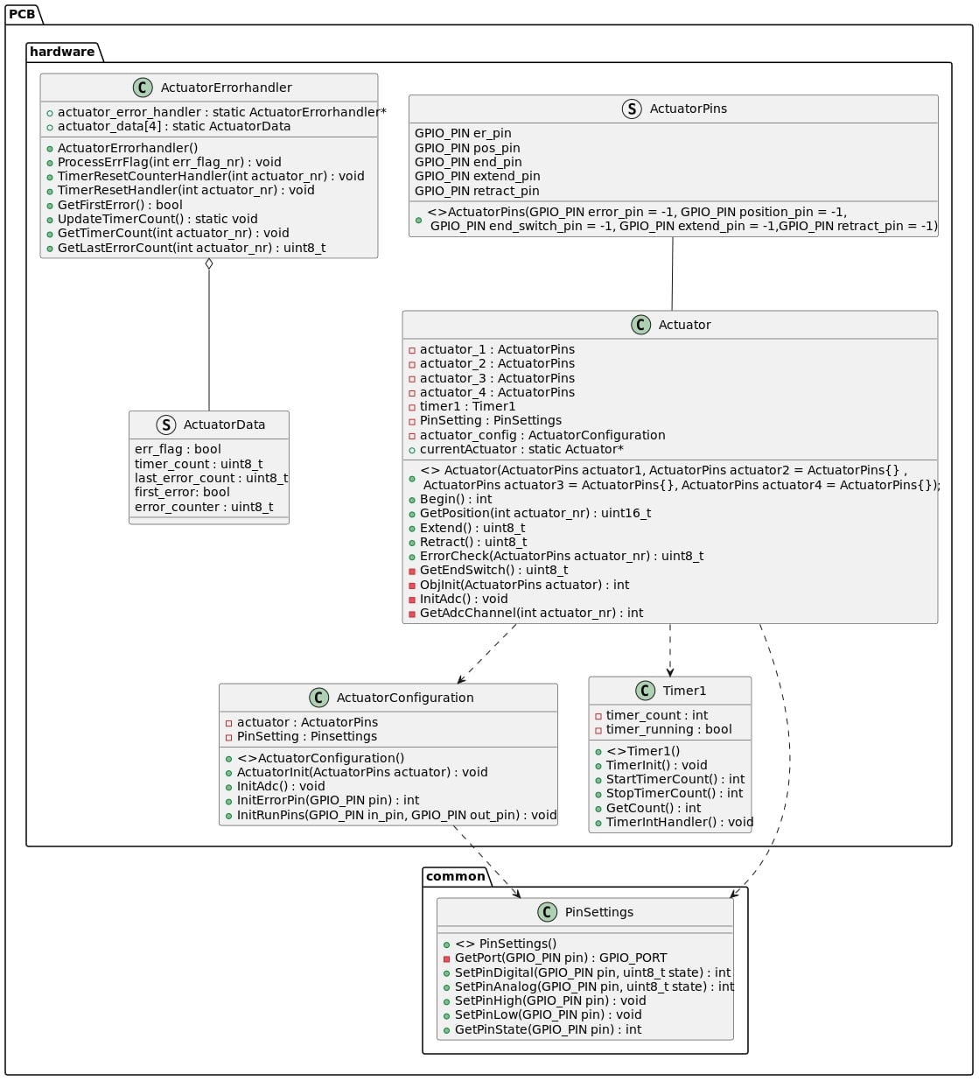

Result
*** Insert Video ***

Triton : Communication

Objective

Approach

Result

PCB : Communication

Objective

Approach

Result

Conclusion(s) and Recommendation(s)

Evaluation and Reflection

References

Attachments

